A000-Eur-Greece-Pergamon-Dying Gaul-Marble-3rd c

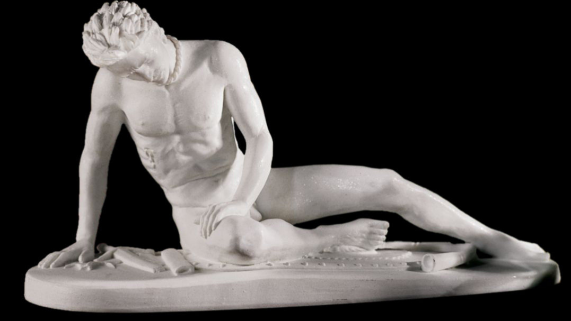

**Case No.:**

**Accession No.**

**Formal Label:** Greece-Pergamon-Dying Gaul by Epigonus -Marble-223 BCE

**Display Description:**

Galeta Morente by Epigonus (223 BCE) Capitoline Museum, Rome. This classic statue is a Roman copy of one of the Hellenistic bronze figures erected at Pergamon by King Attalos 1st (241-197 BCE) commemorating his victories over the Gauls. Despite celebrating triumph, the dignified pathos of the defeated "barbarians" is preserved. The Dying Gaul Statue was \a high level commander of Gallic military forces as indicated by his moustache and neck torque and he exhibits in his pathos strength and bravery which the Greeks admired. Michelangelo restored the damaged right arm.

**Accession Number:**

**LC Classification:**

**Date or Time Horizon:**

**Geographical Area:**

**Map:**

**GPS coordinates:**

**Cultural Affiliation:**

**Media:**

**Dimensions:**

**Weight:**

**Condition:**

**Provenance:**

**Discussion:**

**References:**